**Problem Statement**

**Product Dissection for top leading Platforms**

Welcome to this case study on dissecting and designing products for top leading platforms. In this case study, you will delve into the intriguing world of schema design for a prominent platform of your choice. Your task is to choose a top leading platform, research its features, and meticulously craft a schema design that encapsulates the essence of its functionality. By focusing on key entities, attributes, and relationships, you will gain invaluable insights into how data architecture drives the platform's effectiveness.

**Step 1: Choose a Leading Platform**

Select a leading platform of your choice, which could span various domains such as social media, e-commerce, finance, or any other industry. This choice will form the foundation of your exploration into its schema design.

**Step 2: Research:**

Thoroughly research the platform you have selected. Investigate its core features, functionalities, and user interactions. Identify the top features that define its user experience and contribute significantly to its popularity.

**Step 3: Product Dissection and Real World Problems solved by the platform**

In this step, you will meticulously analyze the platform's standout features and how they provide innovative solutions to real-world challenges. By identifying key functionalities that resonate with users, you'll unravel how the platform effectively addresses problems and enhances user experiences. This dissection will serve as the foundation for understanding how the schema design aligns with the platform's core objectives.

**Step 4: Case Study on the real world problems and approach to solving them**

In this pivotal step, you will expand on the real-world challenges uncovered in Step 3 through a comprehensive case study. Delve into specific instances where users encountered difficulties and showcase how the platform's unique features provided effective solutions. By dissecting the approach taken by the platform to overcome these challenges, you'll gain a deeper appreciation for the platform's user-centric design philosophy and how it shapes the schema design.

**Step 5: Schema Design Based on Top Features**

Based on the features you have identified, craft a schema design that reflects the platform's data structure. Focus on the key entities, attributes, and relationships that underpin the chosen features. Your schema should capture the essence of how the platform organizes and utilizes its data.

**Step 6: Rationale Behind the Design**

While creating the schema design, consider the rationale behind the platform's choices. Reflect on why certain entities and relationships were chosen and how they align with the platform's goals. This will help you understand the strategic decisions driving the schema's architecture.

**Step 7: Create an ER Diagram**

Utilize tools like the Miro platform or similar applications to create an illustrative Entity-Relationship (ER) diagram. This diagram should vividly depict the entities, attributes, and relationships present within your schema design. The ER diagram will serve as a visual representation of your insights.

**Step 8: Presentation of Findings**

Present your findings in a clear and concise manner. Showcase your understanding of how the schema design impacts the platform's functionality and user experience. Explain how your chosen features are integrated into the schema and how the schema's structure supports the platform's objectives.

**Task Details:**

1. **Answer Submission:** Your submission should include well-structured solutions for all provided questions related to product schema designs.

1. **Video Creation:** Create an informative and engaging video where you thoroughly explain the Case Study.

1. **Depth and Clarity:** Ensure your solutions are detailed and showcase your understanding of product schema design principles. Similarly, in the video, provide clear explanations that are easy to understand for a wide audience.

1. **Creativity Encouraged:** You are welcome to utilize visuals, diagrams, or creative elements to enhance the clarity and impact of your explanations.

**Note:**

1. Duplicate this document and proceed to write your solutions and prepare your video.
2. Include the video link in this document before final submission.

Best of luck in completing this project and showcasing your prowess in dissecting and designing product schema for leading platforms!



**Product Dissection for ShareChat**

### **Company Overview**

ShareChat, founded in 2015 by Ankush Sachdeva, Bhanu Pratap Singh, and Farid Ahsan , based in Bengaluru , has quickly become one of India's top social media platforms. It is designed specifically for India's rich mix of languages and cultures. ShareChat has changed the way people in India connect and share content by supporting over 15 regional languages , promoting inclusivity for non-English speakers and bridging the urban-rural digital divide. This platform has become a central place for people, especially from smaller cities and towns (tier 2 and tier 3 cities), where they can express themselves, share posts, and interact with others in their own languages. Its content recommendation system enhances user engagement by tailoring feeds to language and interests. The platform also empowers regional creators and fosters community building. The rapid growth and popularity of ShareChat show how well it has met the unique needs of India's diverse and multilingual population.

__________

### **Product Dissection and Real-World Problems Solved by ShareChat**

ShareChat has smartly tackled many real-world issues by creating a platform that is easy to use, culturally relevant, and accessible to people across India. By focusing on regional languages and local content, ShareChat has solved the problem of digital exclusion for people who don't speak English in India. The platform is designed with the user in mind, making it easy to share content, join language-specific communities, and access a wide range of content types. This has allowed people to connect and engage online in ways that were not possible before.

ShareChat's content recommendation system and community features have addressed the challenge of finding content in multiple languages. The platform recommends content based on users' language preferences and interests, helping them discover new creators, trends, and communities that match their linguistic and cultural background. This not only increases user engagement but also strengthens the sense of community among people who share the same culture and language.

In conclusion , ShareChat has built a platform that supports cultural expression, community building, and digital inclusion in India. By meeting the needs of regional language speakers and providing a space for authentic content sharing and discovery, ShareChat has become an essential part of India's social media landscape.

__________

**Case Study: Real-World Problems and ShareChat's Innovative Solutions**

ShareChat has effectively tackled several significant challenges in India, especially considering the country’s diverse languages and cultures. By understanding its users' specific needs, ShareChat has created solutions that help people connect, share, and engage in meaningful ways.

**Problem 1: Lack of Digital Inclusivity for Non-English Speakers**

**Real-World Challenge :-**  In India, most people prefer to communicate in their regional languages rather than in English. Traditional social media platforms usually focus on English and a few other languages, which makes non-English speakers feel left out, limiting their ability to participate online.

**ShareChat's Solution :-**  ShareChat has solved this problem by supporting over 15 regional languages, allowing users to interact and share content in their native languages. This approach has made social media more inclusive, enabling people from different linguistic backgrounds to fully engage in the digital world. By creating a platform where language is not a barrier, ShareChat has empowered millions of non-English speaking Indians to express themselves online.

**Problem 2: Content Discovery in a Multilingual Environment**

**Real-World Challenge :-**  Finding relevant content in a country as diverse as India can be difficult. People often struggle to find content that matches their language and cultural preferences, which can lead to lower engagement and satisfaction.

**ShareChat's Solution :-**  ShareChat’s advanced content recommendation system curates content based on users' language preferences, interests, and engagement habits. The platform encourages the formation of language-specific communities where users can easily find and share content that aligns with their cultural context. This solution enhances content discovery and strengthens the sense of belonging among users who share similar linguistic and cultural backgrounds.

**Problem 3: Bridging the Urban-Rural Digital Divide**

**Real-World Challenge :-** In India, there is a significant digital divide between urban and rural areas, which makes it harder for people in rural regions to adopt social media. Rural users often have limited access to content that reflects their local culture and interests.

**ShareChat's Solution :-** ShareChat has focused on creating content that resonates with users from smaller cities and rural areas. By emphasizing regional languages and culturally relevant content, ShareChat has made social media more accessible and meaningful for people in rural India. This approach has bridged the gap between urban and rural users, reducing the digital divide and increasing social media use across the country.

**Problem 4: Limited Opportunities for Regional Content Creators**

**Real-World Challenge :-** Regional content creators in India often find it difficult to showcase their work and reach a large audience, which limits their ability to gain recognition and earn money from their content.

**ShareChat's Solution :-** ShareChat has created a supportive environment for regional content creators by offering a platform where they can reach a wide audience that shares their language and cultural background. By focusing on regional languages and communities, ShareChat has helped creators connect with audiences who value their content, leading to greater recognition and opportunities to monetize their work. This has contributed to the growth of India's digital content landscape by empowering regional creators.

**Conclusion :**

ShareChat addresses key challenges in India’s digital space by supporting over 15 regional languages, ensuring inclusivity for non-English speakers. Its user-friendly design promotes easy content creation and interaction, enabling diverse self-expression and community engagement. By personalizing content and fostering community-driven features, ShareChat enhances user experience and bridges the urban-rural digital divide. The platform’s focus on localized content and regional creators helps reduce barriers to digital access, making social media more accessible and engaging for a wide range of users across India.

__________

**Components and Functionalities of ShareChat :**

### **1. User Interface (UI)**

* **Design and Layout :-** ShareChat has a straightforward and easy-to-use design, especially for mobile phones, which is its main focus.
* **Navigation :-** The app uses a bottom navigation bar so users can easily switch between the home feed, explore, notifications, and their profile.
* **Content Feed :-** Users can scroll through an endless feed of content, including text, images, and videos, to keep them engaged.

### **2. User Experience (UX)**

* **Localization :-**  ShareChat supports many Indian languages and offers content that is culturally relevant, not just translated.
* **Personalization** **:-**  The app customizes what users see based on their actions, preferences, and interactions.
* **Community Engagement :-** Features like comments, likes, shares, and hashtags help users interact with each other and make content go viral.

### **3. Content Creation and Sharing**

* **Tools** **:-** Users can create posts with tools for text formatting, image editing, and video recording. They can also add stickers, GIFs, and filters.
* **Content Types** **:-**  Users can post various types of content, including text, images, videos, audio clips, and status updates.
* **Discovery** **:-** The Explore section helps users find trending content, popular posts, and new creators.

### **4. Technology Stack**

* **Backend** **:-**  Likely uses programming languages like Python, Java, or Node.js for managing data and server operations.
* **Frontend** **:-** Uses frameworks like React Native or Flutter to build the app for both iOS and Android.
* **Database** **:-** May use databases like PostgreSQL or MongoDB to store user data and posts.
* **Cloud Services** **:-** Uses cloud platforms like AWS or Google Cloud for storage and scalable services.

### **5. Monetization**

* **Advertisements** **:-** Displays ads in the content feed, using user data to target specific audiences.
* **Brand Collaborations** **:-** Works with brands for sponsored content and marketing campaigns.
* **In-app Purchases** **:-** Offers premium features or virtual items that users can buy to enhance their experience.

### **6. Security and Privacy**

* **Data Protection** **:-** Uses encryption to keep user data secure while being transferred and stored.
* **Privacy Controls** **:-** Allows users to set who can see their content and interact with them.
* **Moderation :-** Uses AI and human moderators to remove inappropriate content and maintain community standards.

### **7. Analytics and Insights**

* **User Analytics** **:-** Monitors user behavior and content performance to improve the app and user experience.
* **Content Insights** **:-** Provides creators with data on how their posts are performing and details about their audience.

### **8. Community and Support**

* **Help Center :-** Offers a help center with FAQs, tutorials, and guides to assist users.
* **Customer Support :-** Provides support through in-app chat, email, or social media.
* **Community Guidelines :-** Has clear rules to ensure a positive and respectful community.

### **9. Growth and Expansion**

* **User Acquisition** **:-** Uses strategies like referral programs, social media campaigns, and partnerships to attract new users.
* **Market Penetration :-** Focuses on expanding within India by adding more languages and localized content.

### **10. Future Developments**

* **New Features :-** Continually adds new features like live streaming, e-commerce options, and augmented reality (AR) experiences.
* **International Expansion :-** Plans to enter new markets, adapting the platform for different languages and cultures.

__________

**Schema Description :**

The structure (schema) of ShareChat is made up of different parts, each representing a specific feature of the platform. The schema for ShareChat includes several key entities: User, Post, Comment, Tag, Notification, and Follower. Each entity has its own set of attributes that describe its characteristics and how it connects with other entities.Relationships include users creating posts, commenting, receiving notifications, tagging posts, and following each other :

### **User Entity :**

Users are central to ShareChat, and the User entity contains essential details about each individual.

* **UserID (Primary Key) :-** A unique identifier for each user. This is a unique number or code that distinguishes one user from another.
* **Username :-** The name chosen by the user for their profile. It’s how other users identify them on the platform.
* **Email :-** The user’s email address used for account communication and recovery. This is essential for notifications and password resets.
* **Password :-** A secure password chosen by the user to protect their account. It ensures that only the user can access their account.
* **PhoneNumber :-** The user’s phone number for account verification and security purposes. It can also be used for notifications.
* **ProfilePicture** **:-** An image chosen by the user to represent themselves on their profile. This is visible to other users and helps in personalizing the user experience.
* **LanguagePreference :-** The primary language chosen by the user for interacting with the platform. It helps in personalizing the content displayed to the user.

### **Post Entity :**

Posts are the core content shared on ShareChat.

* **PostID (Primary Key) :-** A unique identifier for each post. This distinguishes one post from another.
* **UserID (Foreign Key referencing User Entity)** **:-** The ID of the user who created the post. It links each post to its creator.
* **Content :-** The actual content of the post, which could be text, an image, a video, or other forms of media.
* **PostType :-** The type of content in the post, such as text, image, or video. This categorizes the post based on its format.
* **CreatedAt :-** The date and time when the post was created. This helps in tracking and displaying posts chronologically.

### **Comment Entity :**

Comments allow users to engage with posts.

* **CommentID (Primary Key) :-** A unique identifier for each comment. It ensures each comment can be uniquely referenced.
* **PostID (Foreign Key referencing Post Entity) :-** The ID of the post that the comment is related to. It links the comment to the specific post.
* **UserID (Foreign Key referencing User Entity) :-** The ID of the user who wrote the comment. It identifies the commenter.
* **Content :-** The text of the comment. This is what the user has written in response to the post.
* **CreatedAt :-** The date and time when the comment was posted. This helps in ordering comments chronologically.

### **Tag Entity :**

Tags are used to categorize and group content.

* **TagID (Primary Key) :-** A unique identifier for each tag. This distinguishes one tag from another.
* **TagName :-** The text of the tag. This is the keyword or phrase used to categorize posts.

### **Notification Entity :**

Notifications keep users informed about activities related to their account.

* **NotificationID (Primary Key) :-** A unique identifier for each notification. It distinguishes one notification from another.
* **UserID (Foreign Key referencing User Entity) :-** The ID of the user who will receive the notification. It links the notification to its recipient.
* **Type :-** The type of notification, such as a like, comment, or follow. It describes the nature of the event.
* **Content :-** The details of the notification. This includes information about what happened, such as "Your post was liked."
* **CreatedAt**: The date and time when the notification was created. This helps in ordering notifications.

### **Follower Entity :**

Followers represent the relationships where users follow each other.

* **FollowerID (Primary Key) :-** A unique identifier for each follower relationship. It distinguishes one follower relationship from another.
* **UserID (Foreign Key referencing User Entity) :-** The ID of the user who is being followed. This indicates the person who has gained a new follower.
* **FollowerUserID (Foreign Key referencing User Entity) :-** The ID of the user who is following. This indicates who is following the user.
* **FollowedAt :-** The date and time when the following relationship was established. This helps in tracking when the following relationship occurred.

### **PostHashtag Entity :**

Links posts to hashtags to categorize and group content.

* **PostHashtagID (Primary Key) :-** A unique identifier for each association between a post and a hashtag. It distinguishes one link from another.
* **PostID (Foreign Key referencing Post Entity) :-** The ID of the post associated with the hashtag. It links the hashtag to a specific post.
* **HashtagID (Foreign Key referencing Hashtag Entity) :-** The ID of the hashtag linked to the post. It connects the post to a particular tag .

.**Relationships between Entities :**

* **User to Post** **:-** A user can create many posts. This means one user is linked to multiple posts they have made.
* **User to Comment** **:-** A user can make many comments. Each user can comment on many posts, and each post can have many comments.
* **User to Notification :-** A user can receive many notifications. Notifications are linked to specific users.
* **Post to Comment :-** A post can have many comments. Each post can have several comments made by different users.
* **Post to Tag** **:-** A post can have multiple tags, and a tag can be associated with many posts. This helps in categorizing posts and making them easier to find.
* **Comment to Comment :-** A comment can have replies. This means comments can have nested responses from other users.
* **User to Follower** **:-** Users can follow and be followed by other users. This creates a network of connections between users.

__________

**ER Diagram :**

ER (Entity-Relationship) diagram clearly shows the relationships and attributes of the entities in the ShareChat schema. This diagram will act as a visual guide, highlighting the key parts of ShareChat's data model. By using this diagram, you'll better understand the complex interactions and connections that shape how the platform works.

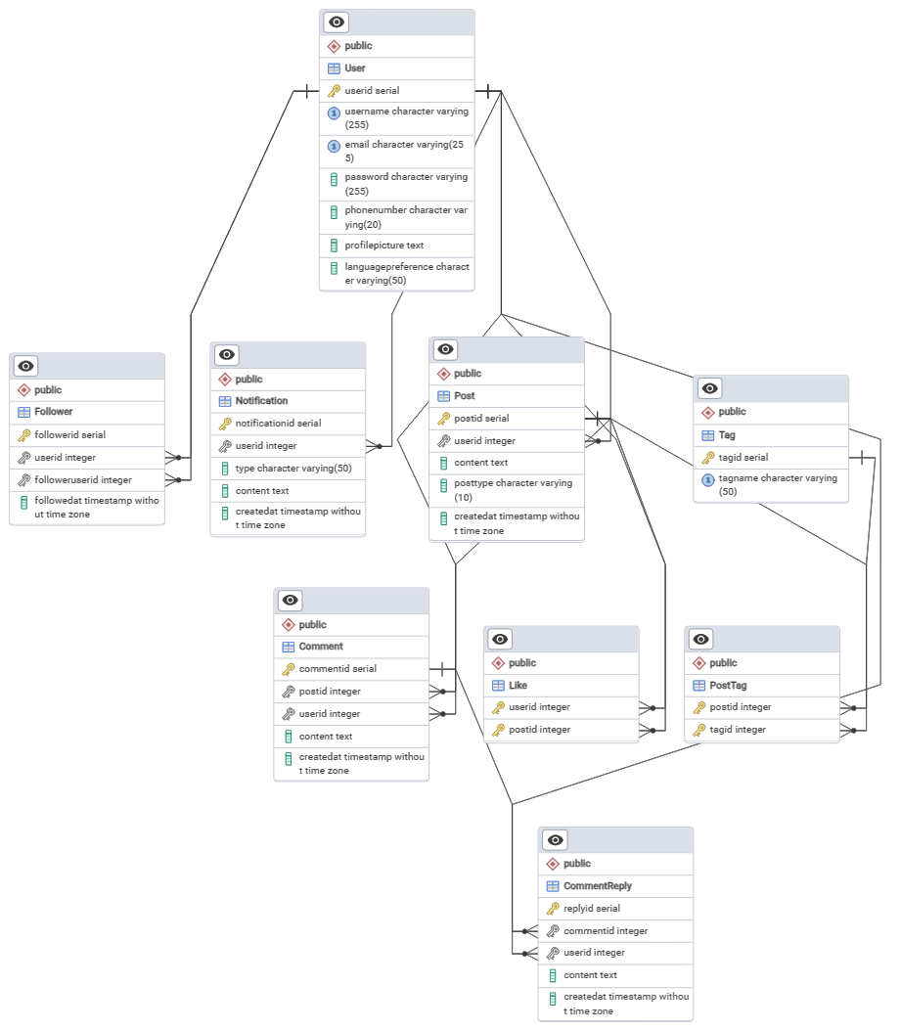

**ER** ( **Entity-Relationship ) Diagram between Entities of SnapChat’s Product**

**__________________________________________________________________**

The ER (Entity-Relationship) diagram for ShareChat shows how different parts of the platform are connected and interact with each other. This visual representation helps to understand the complex relationships and features that shape the user experience on ShareChat.

### **Explanation :**

* **User Table :-**  Contains user details with a unique UserID.
* **Post Table :-** Stores posts created by users, with a foreign key linking to the User table.
* **Comment Table :-** Stores comments on posts, with foreign keys linking to both the Post and User tables.
* **Tag Table :-** Contains tags that can be associated with posts.
* **PostTag Table :-** Manages the many-to-many relationship between posts and tags.
* **Notification Table :-** Keeps track of notifications for users.
* **Follower Table :-** Represents the many-to-many relationship where users follow each other.
* **Like Table :-** Handles the many-to-many relationship between users and posts for likes.
* **CommentReply Table :-** Manages replies to comments, creating a hierarchy of comments.

__________

**Conclusion :**

ShareChat has revolutionized the way people connect and share in India by embracing over 15 regional languages, making social media accessible to everyone. Its easy-to-use design helps users create, share, and discover content that matters to them. By focusing on local languages and content, ShareChat bridges gaps between different regions and supports creators from across the country. This vision of inclusiveness and community has made ShareChat a key player in India's digital world, helping people express themselves and engage more meaningfully in their own languages and cultures.

______________________________________________________